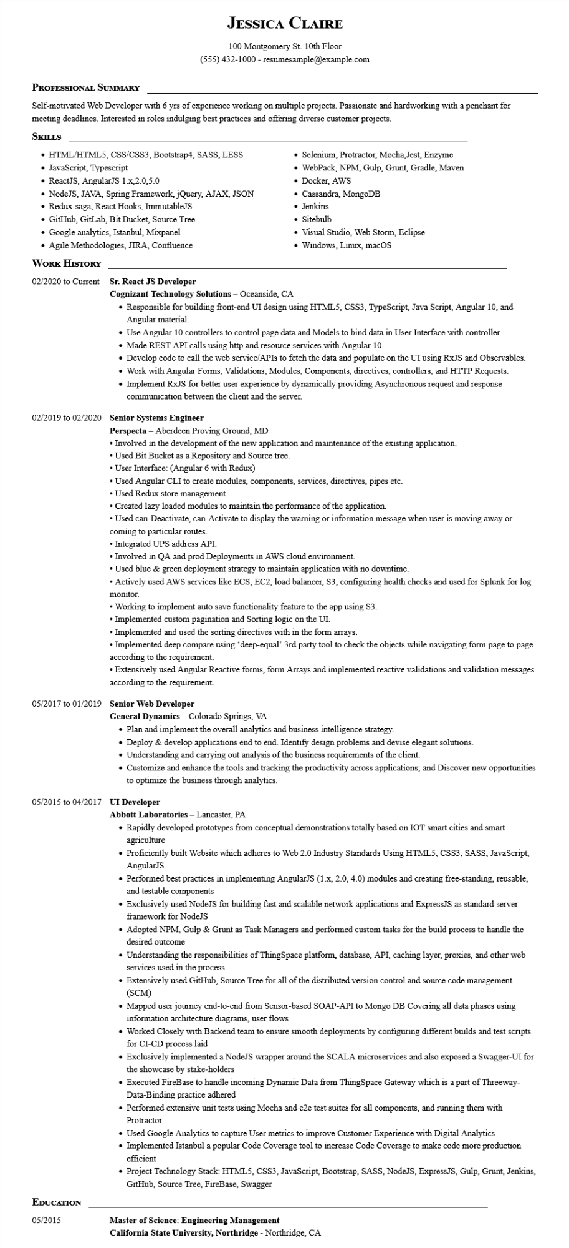
JESSICA CLAIRE
100 Montgomery St. 10th Floor (555) 432-1000 - resumesample@example.com
PROFESSIONAL SUMMARY
Self-motivated Web Developer with 6 yrs of experience working on multiple projects. Passionate and hardworking with a penchant for meeting deadlines. Interested in roles indulging best practices and offering diverse customer projects.
SKILLS
• HTML/HTML5, CSS/CSS3, Bootstrap4, SASS, LESS • JavaScript, Typescript
• ReactJS, AngularJS 1.x,2.0,5.0
• NodeJS, JAVA, Spring Framework, jQuery, AJAX, JSON
• Redux-saga, React Hooks, ImmutableJS
• GitHub, GitLab, Bit Bucket, Source Tree
• Google analytics, Istanbul, Mixpanel
• Agile Methodologies, JIRA, Confluence
WORK HISTORY
02/2020 to Current Sr. React JS Developer
Cognizant Technology Solutions - Oceanside, CA
• Selenium, Protractor, Mocha, Jest, Enzyme
• WebPack, NPM, Gulp, Grunt, Gradle, Maven • Docker, AWS
• Cassandra, MongoDB
• Jenkins
• Sitebulb
• Visual Studio, Web Storm, Eclipse
• Windows, Linux, macOS
• Responsible for building front-end UI design using HTML5, CSS3, TypeScript, Java Script, Angular 10, and Angular material.
• Use Angular 10 controllers to control page data and Models to bind data in User Interface with controller.
• Made REST API calls using http and resource services with Angular 10.
• Develop code to call the web service/APIs to fetch the data and populate on the UI using RxJS and Observables.
• Work with Angular Forms, Validations, Modules, Components, directives, controllers, and HTTP Requests.
• Implement RxJS for better user experience by dynamically providing Asynchronous request and response communication between the client and the server.
02/2019 to 02/2020 Senior Systems Engineer
Perspecta - Aberdeen Proving Ground, MD
• Involved in the development of the new application and maintenance of the existing application.
• Used Bit Bucket as a Repository and Source tree.
• User Interface: (Angular 6 with Redux)
• Used Angular CLI to create modules, components, services, directives, pipes etc.
• Used Redux store management.
• Created lazy loaded modules to maintain the performance of the application.
• Used can-Deactivate, can-Activate to display the warning or information message when user is moving away or coming to particular routes.
• Integrated UPS address API.
• Involved in QA and prod Deployments in AWS cloud environment.
• Used blue & green deployment strategy to maintain application with no downtime.
• Actively used AWS services like ECS, EC2, load balancer, S3, configuring health checks and used for Splunk for log monitor.
• Working to implement auto save functionality feature to the app using $3.
• Implemented custom pagination and Sorting logic on the UI.
• Implemented and used the sorting directives with in the form arrays.
• Implemented deep compare using 'deep-equal' 3rd party tool to check the objects while navigating form page to page according to the requirement.
•Extensively used Angular Reactive forms, form Arrays and implemented reactive validations and validation messages according to the requirement.
05/2017 to 01/2019 Senior Web Developer
General Dynamics - Colorado Springs, VA
• Plan and implement the overall analytics and business intelligence strategy.
• Deploy & develop applications end to end. Identify design problems and devise elegant solutions.
• Understanding and carrying out analysis of the business requirements of the client.
• Customize and enhance the tools and tracking the productivity across applications; and Discover new opportunities to optimize the business through analytics.
05/2015 to 04/2017 UI Developer
Abbott Laboratories - Lancaster, PA
• Rapidly developed prototypes from conceptual demonstrations totally based on IOT smart cities and smart agriculture
• Proficiently built Website which adheres to Web 2.0 Industry Standards Using HTML5, CSS3, SASS, JavaScript, AngularJS
• Performed best practices in implementing AngularJS (1.x, 2.0, 4.0) modules and creating free-standing, reusable, and testable components
• Exclusively used NodeJS for building fast and scalable network applications and ExpressJS as standard server framework for NodeJS
• Adopted NPM, Gulp & Grunt as Task Managers and performed custom tasks for the build process to handle the desired outcome
• Understanding the responsibilities of ThingSpace platform, database, API, caching layer, proxies, and other web services used in the process
• Extensively used GitHub, Source Tree for all of the distributed version control and source code management (SCM)
• Mapped user journey end-to-end from Sensor-based SOAP-API to Mongo DB Covering all data phases using information architecture diagrams, user flows
• Worked closely with Backend team to ensure smooth deployments by configuring different builds and test scripts for CI-CD process laid
• Exclusively implemented a NodeJS wrapper around the SCALA microservices and also exposed a Swagger-UI for the showcase by stake-holders
• Executed FireBase to handle incoming Dynamic Data from ThingSpace Gateway which is a part of Threeway- Data-Binding practice adhered
• Performed extensive unit tests using Mocha and e2e test suites for all components, and running them with
Protractor
• Used Google Analytics to capture User metrics to improve Customer Experience with Digital Analytics
• Implemented Istanbul a popular Code Coverage tool to increase Code Coverage to make code more production efficient
• Project Technology Stack: HTML5, CSS3, JavaScript, Bootstrap, SASS, NodeJS, ExpressJS, Gulp, Grunt, Jenkins, GitHub, Source Tree, FireBase, Swagger
EDUCATION
05/2015
Master of Science: Engineering Management
California State University, Northridge - Northridge, CA

